Adam G Liber

T. Elder

AN1002

March 31 2015

Fieldwork Project: Tourism of Paris

**February 11 2015 14:00, Louvre Central Courtyard**

I am sitting outside the Louvre main courtyard on the fountain ledge. The place is very crowded with an estimate of 500 people. I have heard French, English and 3 or 4 unrecognizable languages and some definitely from Asian roots. I see an older couple one bald man and a well-dressed blonde woman kissing. I see a woman leading to a crowd of predominantly Asian [based on the language the tour guide was speaking] older men and woman the leader carries a green flag. The group behind walks slowly taking pictures with camera and phones. A group of teenager girls mostly blonde girls wearing tight pants and all Nike sneakers take a group photo. They are speaking Dutch or German. I cannot tell for sure. Two women speaking English with British accents walk by one rolling an empty stroller while she says: “Yes, But I have already deleted some photos when it was full” She was holding her phone. Many children walk around playfully while their possible parents follow with empty strollers. I see at least 5 different people at the moment posing while standing on blocks outing their arms out pretending to touch the top of the Louvre pyramid.

“That’s beautiful” one girls says to the other white girl while lift their phones and take a picture of the Louvre. Then, they turn around and take a ‘selfie’ with the pyramid building as well assuming it was for their snapchat story. Now, one blonde, possibly Dutch girl walks by me and makes some joke with the only I recognize as “Selfie” There is a middle eastern looking young couple across from me at the water fountain with his around her. She wears a full body robe and beige headscarf. I see multiple people with rolling suitcases. A young girl is crowded behind me to take pictures of seagulls in the water fountain. Many people are walking in groups in a rush with backpacks some people carry phones on a stick (Selfie stick) to take pictures of themselves “were not gonna make it in time” “Oh wait wait there’s Ryan” “here they are” A couple is wearing matching shoes and beanies but in red and blue. He takes a picture of her from behind while he holds her hand as if she leading him (Aside: I saw a picture gallery on the internet with this same pose perhaps they are imitating this trend) posing for iPhone pictures is clearly the most popular activity.

**February 18 2015 13:00, Louvre: Salle de états Italy**

This is my second visit to he louvre this time I will be focusing on the Mona Lisa as a cultural symbol of art, and its transition into a tourist attraction and possibly social symbol.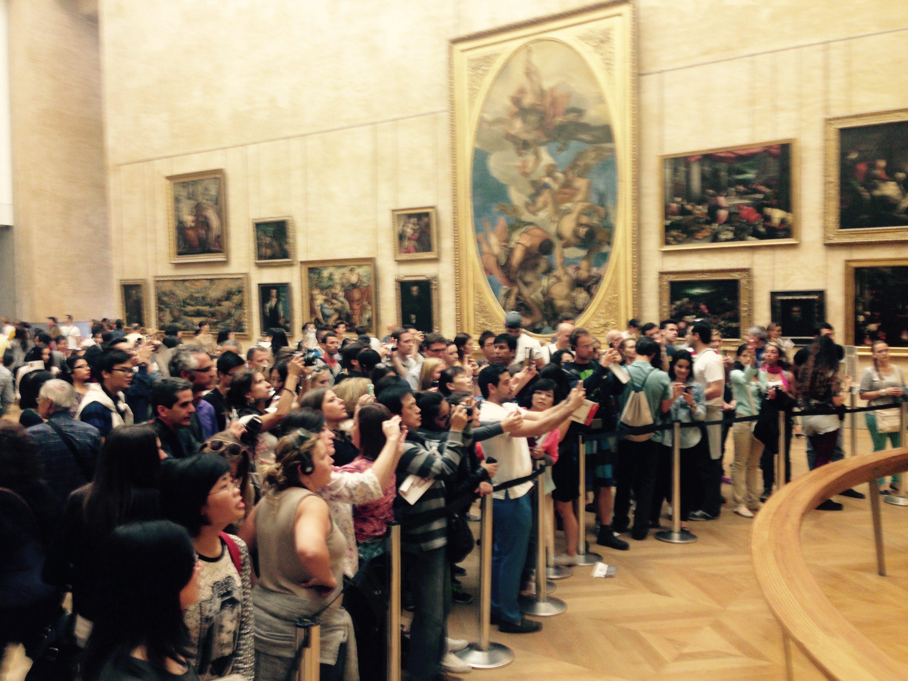

I am in the Salle de états, Italy a highlight exhibit of the louvre particularly dedicated to Italian Renaissance painters. The ceiling is approximately fifteen meters high and the walls are filled with art large to medium in size, of many historically renowned artists such as Caravaggio and Tintoretto. Yet one piece stands alone with the most protection and the most central focus of the exhibit and possibly the entire museum, the Mona Lisa. She sits all day alone on the wall looking out from behind the plexiglass window frame while annually millions of people come and take a photo of and with her. She has been photographed so many times before yet it seems her audience of spectators particularly photographers seems to grow. Crowds of a hundred people push to get closer to her, there are guiding belts and railing to manage the overwhelming crowd. Yet she seems to sit comfortably still and quite day after day. Why do so many people come to get close to her? What makes her so remarkable? She is publicly available on the internet in many versions and high resolution scans, yet still people spend time and money to see her in person. Perhaps there is a universal cultural behavior in getting close to the real historical piece, to witness it with their own eyes. This behavior could be residual feelings of sentiment for genuine originals rather than a copy because access to see the image of her was not as easily available. Perhaps people get a thrill from encountering a piece of history that connects them Experientially with Leonardo Da Vinci through his work. I believe however that it stems from a desire to elevate there own personal social status in the minds of others, thus they use the worlds most famous and most recognizable symbol of art to show via social media to add to their social resume that they are interested in historical arts adding presumed sophistication to there perceived image from others. At the same time recognize the location of the painting to be in Paris. Which acts like other monuments in France is also a prop for photographs to boast to there peers about there travels. However it has become such a trend to take such a photo that it also acts as a symbol of a bonding experience to show that people have shared in common experience. [however because I did not participate in this tourist behavior I am not understanding the reason for it].

**February 25 2015, 15:00 Louvre: Greek Scultpture**

I am in the greek antiquity section of the louvre the main pieces on display are mostly marble sculptures, mainly of greek mythological gods, goddess and other creatures. The male figures are mostly depicted as warriors only wearing armor with muscles bulging and sharply toned, the female figures are also nude but are more plump gentle and smooth. The statues are along the walls and are often segmented or broken from wear over the years. The sculptures are very similar in craftsmanship to my novice perspective, and the artistic value to me is not apparent. I would not be able to distinguished these supposedly original art and historical pieces from plaster copies. One piece is featured in the center of one room and is roped off on all sides, it is a figure of a women weathered looking marble and arms broken off. There is a large crowd surrounding it taking photos and staring at it. I get closer into the crowd and see what people are looking at. The people surrounding vary from teenagers to seniors, some appear to be from Asian countries, some appear to be Americans, and some are French, I can detect this based upon the language and appearance. The young French girls are almost informally wearing black tights, white nike shoes, and green jacket with fluffy edge to their hoods. The Asian youths are mostly wearing jeans and down insulated jackets The Americans are wearing jeans and zip-up cotton hoodies. yet the all seem to be behaving the same. The I see some youths posing and taking pictures in front of it with iPhones. While the older people take photos with cameras strapped around there neck one man has a nikon around his neck and he wears a striped short sleeve button down tucked into his shirt. I hear someone who I believe to be American say “Oh there here it is” while she motions to the statue with the Museum map in hand. I check my own map to see what she is referring to. I notice that this exhibits is listed special on the map with a picture and location tag. [this must be why it draws such a crowd. I could not figure (as a novice) why this piece was any different than the others, and I did not know how others recognize this piece as picture worthy when I don’t think they have any more educational knowledge on this subject. It is probably because it is listed on the map as a notable piece. The tourist must have just come to see it because it was highlighted on the map.]

**March 11 2015 12:00, Louvre: 16th French Academia Art**

I am on the third floor of the Louvre looking for some art by Nicolas Poussin a French classicist artist. I ask an employee for direction in my best french: “Ou set les art de Poussin?” he responds to me in english saying it is “straight down on the opposite end of the hall.” [I am a little upset that he did not think my french skills were enough to respond in french. Or perhaps he just wanted to practice his own english, but his english was very good.] He must have learned english as a skill to accommodate english speaking tourists. I find my way over to the exhibit and the room is not crowded only a few groups of people, walking very slowly staring at one painting or another for extended periods of time. Unlike other places I have studied these people are not actively taking any photos. One man stands with his arms behind his back holding his own hands, with a puzzled look on his face, eyes scanning each painting. There are no young children in this area (or any younger than high school age). I see a small group of students with one adult speaking in french to them. I believe this character to be the school instructor or teacher taking some french students on a class trip, because the kids are mostly wearing backpacks. Some students are taking notes in a notebook while others are quietly in the back of the group whispering to one another while trying not to let the teacher notice. The teacher is pointing to a painting by Poussin called *The Rape of the Sabine Women*. She points to one figure in the painting who is the main dominant figure while saying something in french. From what I understood and my knowledge of the painting I believe she was referencing the figures dress and status relating to Antiquity. Again I notice that none of these students take pictures, which is the most different behavior I can distinguish between this exhibit and other places I have visited. [Perhaps because this room is more obscure and not as visited by first time visitors and thus this room is more scholars rather than those spending leisure time. These people might not be considered tourists at all. Am I a tourist?]

**March 23 2015 approximately 10:00, Eiffel Tower**

It is monday morning the weather is nice and I am with my two tourist friends from Los angeles who will remain anonymous as to protect their privacy. We are walking to the Eiffel tower to climb to the top for fun while i am undercover studying their actions and behaviors as well as other tourist behaviors. Many illegal or legal street vendors are selling items as souvenirs such as miniature Eiffel Towers and other toys and gadgets like selfie sticks. Many people are taking pictures of themselves and each other with the tower in the background. The population of people visibly increases on the Champs de Mars depending on the proximity to the tower. At the base of the tower there are three main lines to enter the structure at respectively south, west and north pillars. the towers offer different modes to climb the tower as well by means of stairs or elevator, the overwhelming majority opt to take the elevator which is expected because tourist are understandably wealthy and spending leisure time. Notably many of the patrons in line are in what appear to be family groups of mostly small children some even including strollers, adding to the reason to take the elevator. This is the first stop requested by my companions on their limited short stay in paris. I notice that another family in line is speaking hebrew which i am quite certain of because I have studied. I have learned from picking my companions up at the airport that flights from Israel to paris are not as frequent as some larger more populated countries thus it is likely that the family group speaking hebrew also came on the same flight suggesting that the Eiffel Tower was also their first choice site destination. I think they are a family because there are two adults one older looking bearded man with a baseball cap and a somewhat younger looking women supervising two adolescents and one child in a stroller which i deduce to be their children. His appearance also is consistent with a man of Israeli and possibly Jewish ancestry that traditionally wear long beards derived from a religious practice. My friends and i stand in line contemplating our route up to the top of the tower. When we get to the ticket booth I present myself as a student with my ID card to the lady in an attempt to obtain a discounted rate, however it is unsuccessful my rate would be the same as my peers. This could be because this site is not qualified in relation to academic study or education despite its historical significance. I believe this qualification might more accurately be because it has many visitors and space is limited so they would not want youths loitering on top of it crowding and possibly disturbing other tourists. Based upon her eye rolling and loud vocalization and repetition of command the lady seemed highly frustrated with my companions because of there cumbersome attempt to understand the rates and payment methods. The lady in the booth spoke english quite well revealing that a relevant sum of the patrons speak english and not french, suggesting they come from America or english speaking country or bilingually educated individuals from other countries. She must have become frustrated with patrons preceding us and the constant repetition of basic information that perhaps patrons are not so focused or time considerate.

**March 25 2015 approximately 10:00, Louvre: underground entrance line**

I am with my two friends visiting from out of town, both americans from Los Angeles on their way home from Israel, they decided to come visit the louvre early morning on wednesday because on tuesday the museum was closed, we step into the underground hall opening into the court entrance from the metro with the inverted glass pyramid meeting a right side up smaller marble pyramid. There are many chain store companies of like Starbucks McDonnell's apple store and name brand jewelry stores that I am not familiar with but I am confident are global brands. There are also many gift shops selling small souvenirs. The walls are covered in advertisements of these brands in and around the louvre appearing as high-class merchandise. as well as many brands I am not familiar with. We immediately see a line from the security check point all the way past the metro the line is equally long outside. They had hoped to see just a few exhibits and particularly the Mona Lisa, the most popular attraction a symbol of the louvre and art all over the world. Without a doubt for first time visitors it is the most wanted piece to see, or perhaps to be seen with (do people come to see the painting or do people come to show that they have seen it? It appears that most people are more concerned with taking a picture of themselves with it in the background.) The estimated line wait is over an hour the longest I have ever seen it and to my knowledge this is wednesday morning has no particular occasion other than possibly coinciding with students spring breaks. I see a large majority of young people waiting in line with people in mostly in groups with no less than two. As we wait in line my companions take their phones out to compare pictures of the trip in paris thus far, I notice that many people around us are also holding their cellphones in hand. I peek over at the group in front of us of what i think to be four friends two male and two female possibly two couples who are friends judging by their proximity to one another and their body language and vocalizations communication affection from what I understand I do not recognize the language however I would guess that it is an asian language based on the short quick abrupt consonants and vowels. Three of them have phones out one has a Samsung Galaxy I believe based on the large size a curve back one has the iPhone 5 and one girl has the iPhone 6. Im not sure but I think two of them are looking at photos on Instagram while the third is scrolling through Facebook (luckily for the trend of larger screened phoned it is easier to peek. The forth character is onlooking over the shoulder of one on Instagram, looking at pictures of their peers probably in other places in the world also on vacations possibly traveling based on a vague beach looking background on an image which must be outside paris.

**Further Study**

To progress my research I would like to focus on the globalization changed the travelers identity from behavior from explorer into tourist. After studying the behavior of tourism particularly in the louvre and the Eiffel Tower I have seen how commercialization and monetization has created a large industry for tourism because of the expanded population of travelers. As a result of the large community of people who travel and participate in this culture and behavior achieving a linked identity despite the fact they come from different nationalities, religions, and languages they have achieved a common identity as “tourists” through shared travel behavior. In addition the most prevalent shared behavior is the practice of photography and I would be interested to study the meaning behind the particular photos travelers take especially how they can vary in meaning while including much of identical content. I plan to analyze the transition from explorer into tourist identity study the change in documentation behavior of exploration and identity of the “tourist” through photography in the 19th and 20th century. Conversely another option of research would be into the inhabitants and residents of the place visited by tourists and how that affects their own lives. Some places the majority of the economy is driven by the tourist industry and yet some would argue that the original cultural identity in those places has diminished or dissolved in the overwhelming number of tourists. I would like to study this effect of tourism from the perspective of the original inhabitants. Furthermore I could study the formation of certain locations where the majority of people are visitors in contrast with other native towns. I would read and reread in the *Jack David Eller Cultural Anthropology Global Forces* including but not limited to: the method of studying cultural dynamics, the relationship of “the other,” establishment of identity, economics, struggle for cultural survival. Side research texts might include [*Sustainable tourism innovation*](http://www.jstor.org/stable/10.2307/23746748?Search=yes&resultItemClick=true&searchText=tourism&searchUri=%2Faction%2FdoBasicSearch%3FQuery%3Dtourism%26amp%3Bacc%3Don%26amp%3Bwc%3Don%26amp%3Bfc%3Doff%26amp%3Bgroup%3Dnone)*: Challenging basic assumptions* by Christian M. Robertson. [*Sustainable Tourism: Ethical Alternative*](http://www.jstor.org/stable/10.2307/25075360?Search=yes&resultItemClick=true&searchText=tourism&searchUri=%2Faction%2FdoBasicSearch%3FQuery%3Dtourism%26amp%3Bacc%3Don%26amp%3Bwc%3Don%26amp%3Bfc%3Doff%26amp%3Bgroup%3Dnone) *or Marketing Ploy?* by Paul Lansing.